Mini Project - 3

|  |  |
| --- | --- |
| **Student Name/ID Number:** | Ida Bagus Ketut Yoghantara |
| **Unit Number and Title:** | ACWD Module 4 – Database Design & Implementation |
| **Academic Year:** | 2022 |
| **Unit Assessor:** | Arvinder Kaur |
| **Project Title:** | Develop Sample Data, Queries or Report, Test & Document Database |
| **Issue Date:** |  |
| **Submission Date:** | 2 Agustus 2022 |
| **Internal Verifier Name:** |  |
| **Date:** | 31 July 2022 |

|  |
| --- |
| **Learner declaration** |
| I certify that the work submitted for this assignment is my own and research sources are fully acknowledged.  Student signature:  Date: 31 July 2022 |

|  |
| --- |
| **Purpose of this project** |
| **Purpose of this project**  To demonstrate your capabilities in the following areas:   * Develop Sample Data for Reports * Develop Queries & Report * Test Database * Document Database |
| **Submission Format** |
| 1. Screen capture of Sample Data for Report 2. Queries for generating reports from database 3. Detailed description of Test Methods 4. Documentation of Database |
| **Project Brief & Guidance** |
| **Scenario:**  **Refer to the Project Scenario for the Module Project**  You have been approached by ‘ABC Jobs Pte Ltd’ as a website developer to develop a community portal for Software Developers. The project will be carried over through Module 3, Module 4, Module 5 and Capstone project. For this module the scope is to Design, Develop, Implement & Document Struts Framework Website.  The Scope of the Project is to design a Community Portal Similar to Linkedin.com. Users will be able to register in the portal using the Registration Page. Users of the portal can search for other users using various parameters such as First Name, Last Name, Company Name, City & Country. Users will be able to view the Public Profile of users after searching them. The portal allow users to login, request for forgotten password and Update their profile information  The scope of this mini project is to generate reports, test and document database.  **The overview of the project is as below**  There are 2 types of users in this Community portal. They are   1. Software Programmer 2. Administrator |

|  |
| --- |
| **Software Programmer should be able to perform following functions in the portal**   1. Allow the programmers to register in the portal, show a thank you page & send a registration confirmation email. 2. Search & Find Other Programmers after login and view their profile. 3. Provide Login Page 4. Provide password retrieval functionality. 5. Update their Profile after logging in.   Following Functionality is part of Database Design & Will be enhanced as features as required in the Capstone Project, Depending on time availability.   1. Send Messages to Each Other on the Portal 2. Create Threads & Post Replies to a Thread 3. Post Job Opportunities in the Portal   **Administrator should be able to perform following functions in the portal**   1. Administer user data. 2. Send bulk email inviting programmers to register on the community portal   **The portal consist of the following Key pages (For Reference)**   1. Community Portal Home Page 2. Registration Page 3. Registration Confirmation Page 4. Update Profile Page 5. Search Users Page 6. List Search Results 7. Public Profile Page 8. Registration Confirmation Email 9. Login Page 10. Forget Password Page 11. Design the Forget Password Confirmation Page   Following Functionality is part of Database Design and will not be part of development & Will be enhanced as features are required in the Capstone Project, Depending on time availability.   1. Send Messages 2. Read Messages 3. Post in Message Board 4. List Message Board 5. Read A Thread 6. Post Job Opportunities 7. List Job Opportunities & Responses   **The scope of this assignment**   1. Create test data for all tables suitable for generating reports 2. Design report and Create queries which will be used for generation of meaningful management reports. Present the report in HTML format (1 report) |

1. Discuss briefly test methods you will employ to test and validate the database and brief reasons why you choose each test.
2. Document the database
3. Create a batch script to backup database & schedule it to run every 6 hours using windows task scheduler. Provide the script, along with the screen capture of Windows Task scheduler.
4. Provide a Restoration script in case of failure
5. Create test data for all tables suitable for generating reports

|  |  |
| --- | --- |
| Table | Tb_users |
| SQL Query | INSERT INTO tb_users (email, password) VALUES  ('user@gmail.com', 'user123'),  ('user2@gmail.com', 'user123'),  ('user3@gmail.com', 'user123'),  ('user4@gmail.com', 'user123'),  ('user5@gmail.com', 'user123'),  ('mmeth0@ftc.gov', 'SNLlLD1C2'),  ('acurthoys1@europa.eu', 'cNyuo5f7i'),  ('wkeddy2@engadget.com', 't97gBuwzVY'),  ('dpapps3@usa.gov', 'zM1DrmWgB'),  ('gwillingham4@samsung.com', 'Gj5N05udhj6'),  ('mmalletratt5@php.net', '6coX4Yv'),  ('rcheine6@businessinsider.com', 'Cak7WSHkA'),  ('bbelone7@skyrock.com', 'lBUtP5YBa7FR'),  ('kfelstead8@bbb.org', 'BuYRvUnATH'),  ('msjostrom9@china.com.cn', 'opZ9kYrwV'),  ('agamwella@github.com', 'j1DeKMT36'),  ('sfreakb@icio.us', 'SDwFFvl6GLT'),  ('zizzatc@1688.com', 'VcqX0fJwSn46'),  ('kmozzid@xrea.com', '1kC9ynIYK'),  ('lfoffanoe@blinklist.com', 'GaoynOk2KOZh'),  ('oskentelburyf@msu.edu', 'iN0AzkB04CAE'),  ('tsydeg@nydailynews.com', 'H27mgf'),  ('cdetloffh@spotify.com', '0SpHIon'),  ('tgarletti@house.gov', 'E9Cmq7EVR'),  ('lseyj@java.com', 'ovyfBubXJpJl'); |
|  |  |

|  |  |
| --- | --- |
| Table | Tb_user_profile |
| SQL Query | INSERT INTO tb_user_profile (fk_id_user, fk_id_job, first_name, last_name, country, city)  VALUES (1, 1, 'Putri', 'Puspita', 'Indonesia', 'Bali'),  (2, NULL,'Dayu', 'Ratih', 'Indonesia', 'Medan'),  (3, 2, 'Ricky', 'Tegar', 'Indonesia', 'Balik Papan'),  (4, NULL,'Yopha', 'Candra', 'Indonesia', 'Jakarta'),  (5, 3, 'Yoga', 'Setiawan', 'Indonesia', 'Aceh'),  (6, NULL ,'Loydie', 'Clemerson', 'Egypt', 'Kafr ad Dawwār'),  (7, 2, 'Kim', 'Maffeo', 'Nigeria', 'Lame'),  (8, 3, 'Marie', 'Sackey', 'China', 'Sancha'),  (9, 4, 'Kath', 'Soitoux', 'Greece', 'Kalloní'),  (10, 1, 'Isabelita', 'Sermin', 'Sweden', 'Säter'),  (11, NULL, 'Justino', 'Gwyn', 'Slovenia', 'Rače'),  (12, NULL, 'Kaiser', 'Rex', 'China', 'Lengkeng'),  (13, 2, 'Benedicta', 'Candie', 'Greece', 'Xinó Neró'),  (14, 1, 'Carmine', 'Galtone', 'France', 'Nanterre'),  (15, 3, 'Patti', 'Bickerdicke', 'Japan', 'Ōkawa'),  (16, NULL, 'Muhammad', 'Westgate', 'Palestinian Territory', 'Birqīn'),  (17, 1, 'Meade', 'Jumel', 'Greece', 'Vanáton'),  (18, 4, 'Gage', 'Kennard', 'Portugal', 'Évora'),  (19, 4, 'Kristoffer', 'Thaine', 'Nepal', 'Pātan'),  (20, 5, 'Solly', 'Ketchell', 'Indonesia', 'Batanghari'),  (21, 6, 'Ike', 'Bartell', 'China', 'Tangnanzhen'),  (22, 4, 'Nobie', 'Berens', 'China', 'Huanggang'),  (23, 6, 'Ferdy', 'Pidgeley', 'Ethiopia', 'Nazrēt'),  (24, 5, 'Kurt', 'Perree', 'United States', 'San Antonio'),  (25, 6, 'Letisha', 'Lightowlers', 'Saudi Arabia', 'Al Jarādīyah'); |
|  |  |

1. Design report and Create queries which will be used for generation of meaningful management reports.

|  |  |  |
| --- | --- | --- |
| No | Note | Query |
| 1 | All users profile information.  To fetch user profile information and their job. | SELECT UP.id_user_profile AS Id_User,  CONCAT(UP.first_name, ' ', UP.last_name) AS Name,  CONCAT(UP.country, ', ', UP.city) AS Address,  J.job_name AS Job  FROM tb_user_profile AS UP  LEFT JOIN tb_jobs AS J ON (UP.fk_id_job = J.id_job)  UNION  SELECT UP.id_user_profile AS Id_User,  CONCAT(UP.first_name, ' ', UP.last_name) AS Name,  CONCAT(UP.country, ', ', UP.city) AS Address,  J.job_name AS Job  FROM tb_user_profile AS UP  RIGHT JOIN tb_jobs AS J ON (UP.fk_id_job = J.id_job)  ORDER BY Name; |

Report user profile information  
  
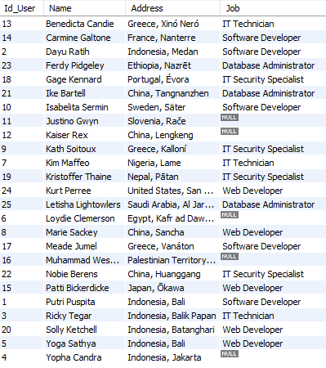

1. Discuss briefly test methods you will employ to test and validate the database and brief reasons why you choose each test.
2. **Structural Database Testing**
   * **Schema Testing.**

Schema or database testing is vital in ensuring the validity of data received and stored into database.

|  |  |  |  |  |
| --- | --- | --- | --- | --- |
| No. / Test Cases | Expected Result | Actual Result | Test Result | Evidence |
| 1. Schema Testing: Ensure that Relationship Schema and EER Diagram is the same in terms of (table name, attributes, primary key and foreign key) | Both Relationship schema and EER diagram should have similar field of: table name, attributes, primary key and foreign key | Both Relationship schema and EER diagram is the same in terms of (table name, attributes, primary key and foreign key)  *See diagram in next page | Pass | Screen capture of logical design and physical design (EERD) |

**Evidence:**

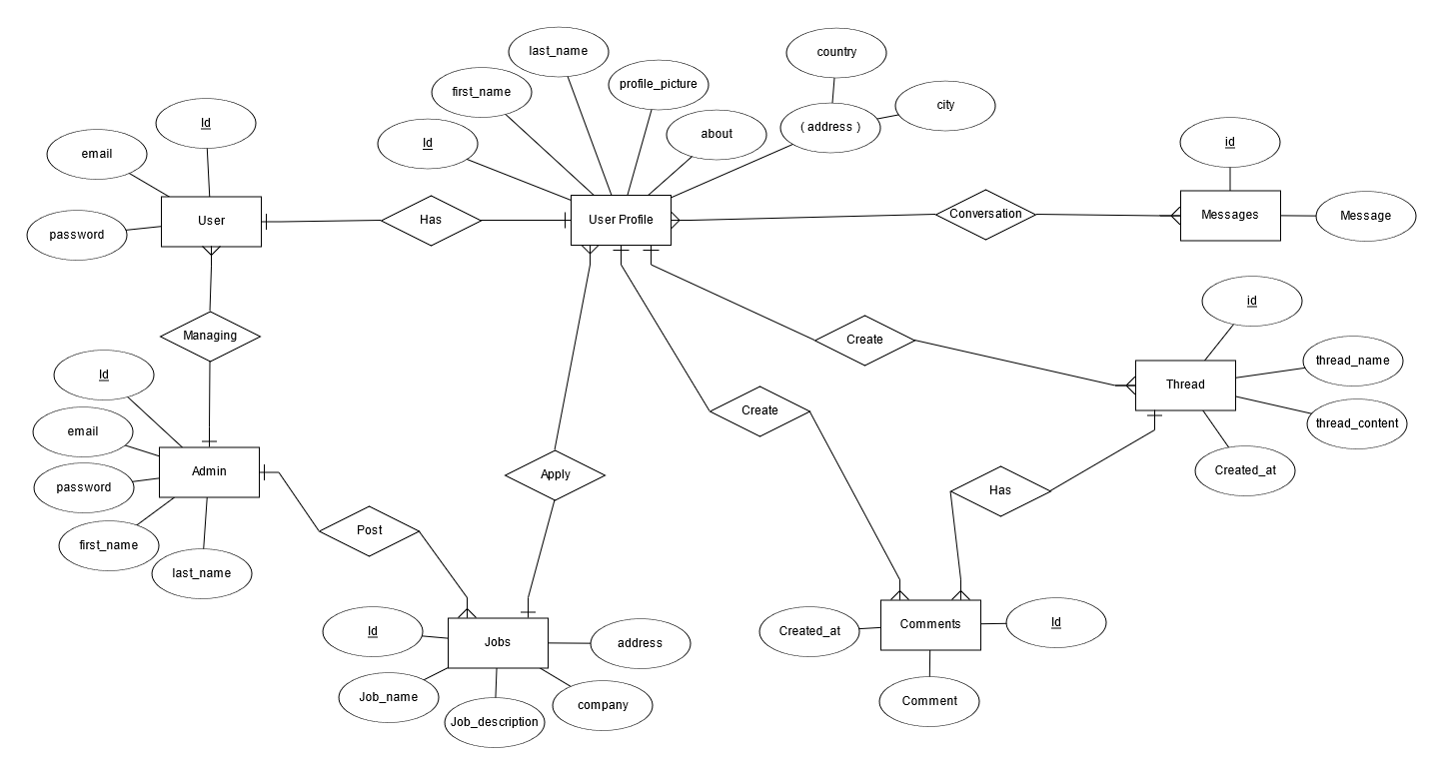

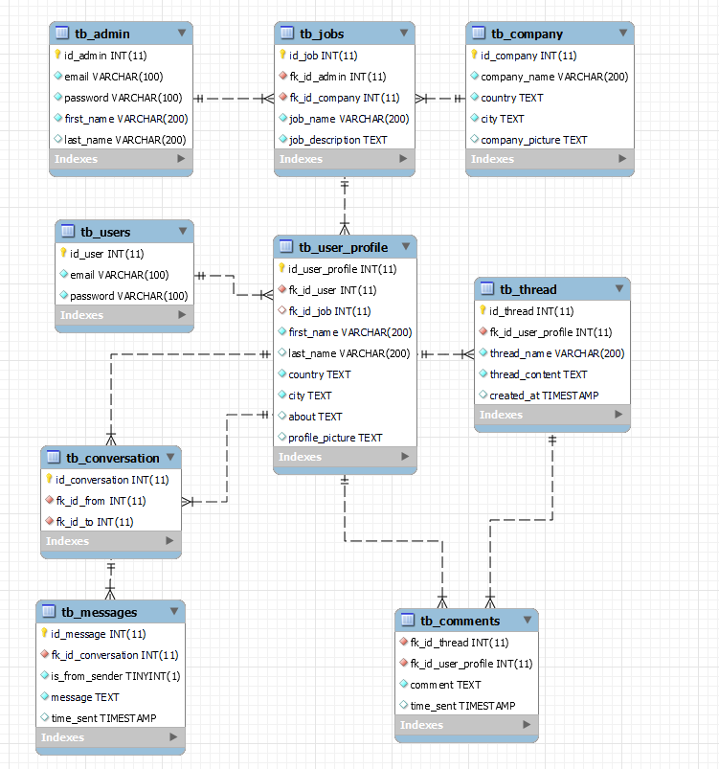

* + **Table/column testing.**

Every transaction or sequence of operations performed using SQL statement must conform to the ACID properties validation.

**Table/columns testing**

|  |  |  |  |  |  |
| --- | --- | --- | --- | --- | --- |
| Test Case ID | Test case | Expected result | Actual result | Pass / Fail | Evidence |
| TC01 | 1. Primary Key testing: Insert duplicate value for primary key column for ‘users’ table | Error message should appear because duplicate value will be inserted into primary key column violating the rule | Error message appear because duplicate value is inserted into primary key column | Pass | Evidence screen capture No TC01 |

**Evidence**

**TC01:**

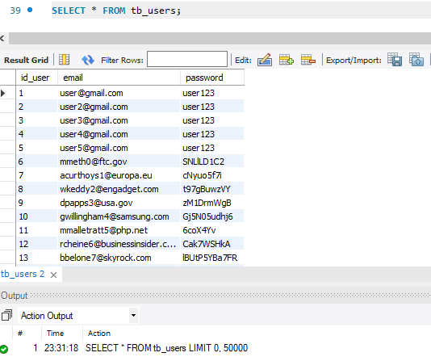 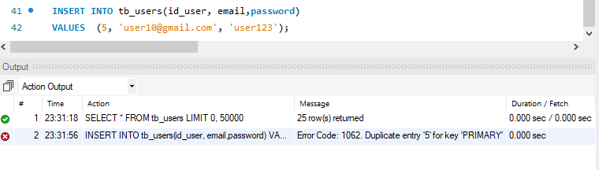

1. **Functional Database Testing**

Functional database testing is to test whether data in the database can be access and updated by the users and applications. all CRUD

|  |  |  |  |  |  |
| --- | --- | --- | --- | --- | --- |
| Test Case ID | Test Case | Expected Result | Actual Result | Test Result | Evidence |
| FC001 | Insert record into ‘users’ table | A record should successfully insert into 'user' table. | Record is successfully inserted into ‘user’ table | Pass | FC001 |
| FC002 | Update record in ‘users’ table | Data should be successfully updated | Data successfully updated | Pass | FC002 |
| FC003 | Delete record in ‘users’ table | Data should be successfully deleted | Data successfully deleted | Pass | FC003 |

**Evidence:**

**FC001**

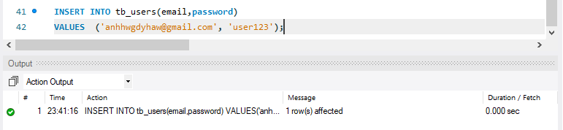

**FC002**

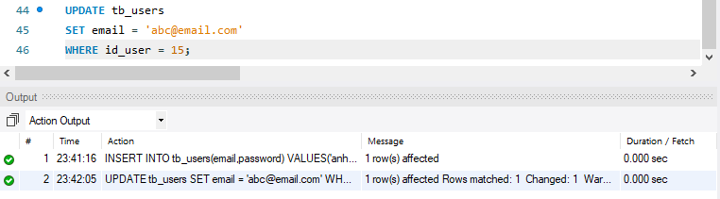

**FC003**

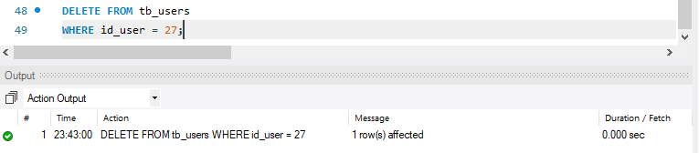

1. **Non-Functional Database**

Non – functional specify on the quality of a database characteristics or attributes based on performance, capacity, data integrity, security and more. This requirement describes more on how the product works through testing like load, stress, security and others

* + **Load Testing**

Load testing test frequently accessed transactions impact on the database performance.

This testing involves simulating real-life cases when multiple users load simultaneously (Database Testing – Performance, n.d.) .

**Test Plan**

|  |  |  |  |
| --- | --- | --- | --- |
| No | Test case | Note | Evidence |
| 1 | Auto generate | Test performance of the device for simple test using auto generate from the mysqlslap with 50 users and 10 repetitions. | Load test 1 |
| 2 | custom query from the auto generates | Test performance with custom query using schema from auto generate with 50 users and 100 repetitions. | Load test 2 |

**Load test 1**

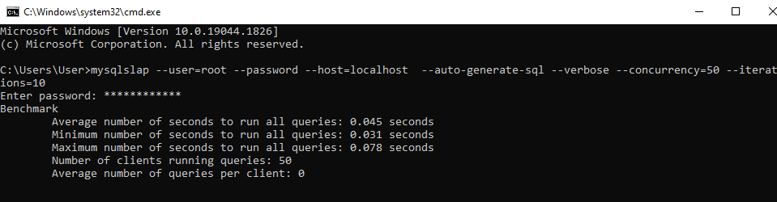

**Load test 2**

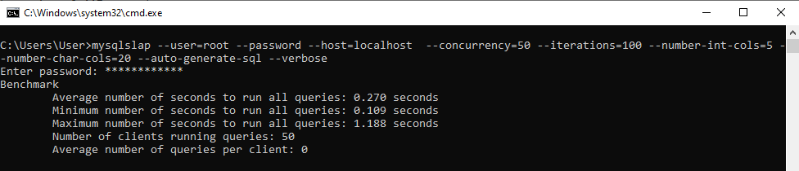

1. Document the database  
     
   tb_admin

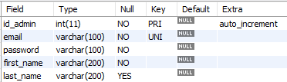

Tb_users

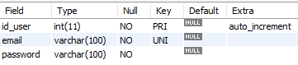

Tb_user_profile

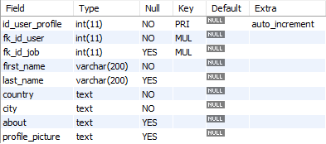

Tb_jobs

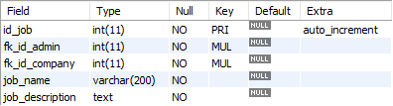

Tb_company

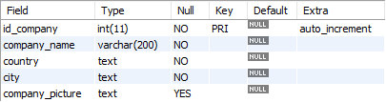  
  
tb_conversation

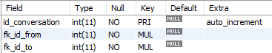

Tb_messages

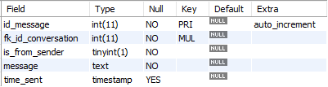

Tb_thread

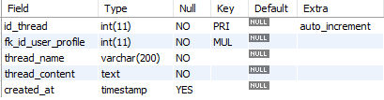

Tb_comments

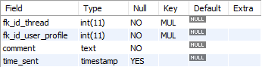

1. Create a batch script to backup database & schedule it to run every 6 hours using windows task scheduler. Provide the script, along with the screen capture of Windows Task scheduler.  
     
   backup_abc.bat  
   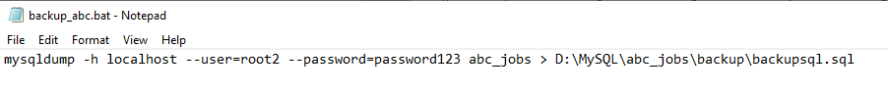   
    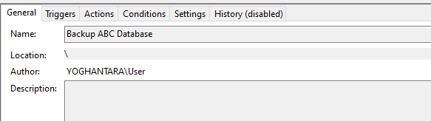   
     
   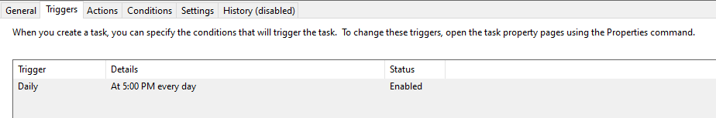  
     
   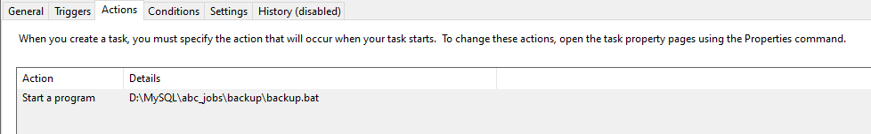
2. Provide a Restoration script in case of failure  
     
   **mysql -h localhost -u root -p abc_jobs_backup < D:\MySQL\abc_jobs\backup\backupsql.sql**